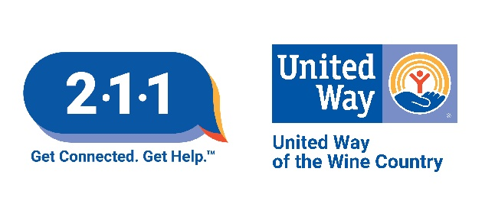

211 SERVICE PROVIDER APPLICATION

Thank you for your interest in having your agency included in the 211 database.

The application includes two basic areas:

1. Agency Information: This section covers general information about your organization. It does not include individual program information.
2. Program Information: This section covers the programs (or services) your agency provides. Please complete one program section for each program you are submitting for the 211 database.
You will also be asked to provide location details, such as the address(es) where each program is offered.

Send the completed application by email (211sonoma@icfs.org)

Please do not hesitate to contact the 211 Sonoma County Resource Team if you have questions or need assistance with this process.

We look forward to receiving your application.

Thank you,
211 Sonoma County Resource Team
211sonoma@icfs.org
SERVICE PROVIDER APPLICATION/UPDATE FOR 211 SONOMA
AGENCY INFORMATION
Inclusion Criteria
Does your organization provide services that are appropriate for inclusion in the 211 database, based the 211 Sonoma County Inclusion/Exclusion Policy (available at www.211sonoma.org)? Yes No
Have you been in operation for at least six months? Yes No
General Agency Information
Agency Name:
Is your agency also commonly known by another name or abbreviation:
Parent Agency (If legally part of another organization:
Agency Description (describe your agency in one or two sentences):
e.g. Nonprofit organization focused on supporting individuals with disabilities.
Agency Type:
Not-for-profit (incorporated) - tax designation 501(c)(3) 501(a) Other:
Not-for-profit (not incorporated)
Government: If Yes, which level? Federal State County City
For Profit/Commercial
Agency Contact Information
Agency Website/URL: |  | Agency Email:  (for general questions from the public)
Physical Address  Agency Physical Address:  City, State: Zip: |  |  | Is this office:  A confidential location? Yes / No  Wheelchair accessible? Yes / No
Mailing Address Same as above (if mailing address is different, add address below)
Agency Mailing Address:
City, State: Zip:
Administration Office Hours:
Mon Tues Wed Thurs Fri Sat Sun
What holidays does your agency close for?
Agency General Information Phone #: Fax #: TDD/TTY #:
Agency Senior Executive Name: Title:
Phone: Email:
Agency Primary Contact for 211
This person will receive the 211 annual update request to confirm and/or update your agency’s information in the 211 database and will be contacted if there are questions about your agency’s information in the 211 database. To ensure the accuracy of referrals, agencies that do not respond to the annual update will be subject to removal.
Name: Title:
Phone: Email:

PROGRAM INFORMATION
(Please submit one Program Information section per program)
Agency Name: |  | Program Name:
Is this program commonly known by another name or abbreviation?
Program Website/URL: |  | Program Email Contact:
Program Description/Primary Services
Maximum of 100 words.
e.g. Provides parenting skill classes to parents struggling with managing misbehavior of their children at home or school.

Intake Procedure: Walk-In Call for appointment Referral required from Other:
Documentation Required at Intake (i.e. ID, SS card, Proof of Income etc.):

Program eligibility requirements:  No restrictions or eligibility criteria.  Other:  e.g. Must be parents with children under 18 years old. |  | Residency requirement:  No residency requirement  Must be a citizen of United States  Must be a California resident  Must by a Sonoma County resident  Must be resident of specific city:  Must be resident of specific zip code:
Fees (check all that apply):  No Fee  Fees vary  Sliding Scale fee $ to $ based on  Set program fee $ per |  | Accepts Medi-Cal  Accepts Medi-Care  Accepts most insurance  Membership fee $ per
Program Hours:
Mon Tues Wed Thurs Fri Sat Sun Hours vary
Language - Service is available in:
English Spanish Other: Interpreter Services Available for:
PHONE NUMBERS
Main Program Phone #:
Other Phone #: Purpose of Other Phone (i.e. Afterhours 5pm-8am):
TDD/TTY Phone #:
Agency Name: Program Name:
Program is offered at this location (“Site A”)
Site Name:
e.g. ABC Family Resource Center, Main Office, Valley Clinic
Physical Address  Agency Physical Address:  City, State: Zip: | Is this office:  A confidential location? Yes / No  Wheelchair accessible? Yes / No
Mailing Address Same as above (if mailing address is different, add address below)
Agency Mailing Address:
City, State: Zip:
Program is offered at this location (“Site B”)
Site Name:
Physical Address  Agency Physical Address:  City, State: Zip: | Is this office:  A confidential location? Yes / No  Wheelchair accessible? Yes / No
Mailing Address Same as above (if mailing address is different, add address below)
Agency Mailing Address:
City, State: Zip:
Program is offered at this location (“Site C”)
Site Name:
Physical Address  Agency Physical Address:  City, State: Zip: | Is this office:  A confidential location? Yes / No  Wheelchair accessible? Yes / No
Mailing Address Same as above (if mailing address is different, add address below)
Agency Mailing Address:
City, State: Zip:
** Add information for additional physical locations as needed.

SUBMITTED BY
NAME: DATE:
TITLE:

EMAIL: PHONE:
SUBMIT APPLICATIONS/UPDATES VIA EMAIL
211 Sonoma County
(707) 806-0548
211sonoma@icfs.org * https://211sonoma.org/

